**DEPARTMENT OF COMPUTER SCIENCE AND ENGINEERING**

**Machine Learning Based DNS Tunnel Detection system**

**NETWORK PROGRAMMING AND SECURITY**

**CS362IA**

| **USN** | **Name** |
| --- | --- |
| 1RV22CS186 | SHREEHARI G BHAT |
| 1RV22CS191 | SHREYAS KRISHNNASWAMY |
| 1RV22CS201 | SRAVANI H |

**Mentor**

**DR. SANDHYA S**

**ASSOCIATE PROFESSOR**

**DEPT. COMPUTER SCIENCE & ENGINEERING**

**2024-2025**



**CERTIFICATE**

Certified that the **NPS Lab Component** titled “**Machine Learning Based DNS Tunnel Detection system**” is carried out by **Shreehari G Bhat (1RV22CS186), Shreyas Krishnaswamy(1RV22CS191), Sravani H(1RV22CS201),** who are bonafide students of RV College of Engineering, Bengaluru, in fulfillment for the **NPS Lab Component** during the year 2024-2025. It is certified that all corrections/suggestions indicated for the Internal Assessment have been incorporated in the report deposited in the departmental library.

**Signature of Lab Incharge**  Signature of Head of the Department

**Dr. Sandhya S** **Dr.** [**Shantha Ranga Swamy**](mailto:shantharangaswamy@rvce.edu.in)

**Name of Examiners Signature with Date**

**1**

**2**

**ABSTRACT**

The Domain Name System (DNS) is a critical backbone of modern internet communication, responsible for translating human-friendly domain names into machine-readable IP addresses. While essential for day-to-day networking, DNS is often overlooked in security monitoring and has become a preferred vector for attackers to establish covert channels using a technique called DNS tunneling. In DNS tunneling, malicious actors embed payloads within DNS queries and responses, enabling unauthorized data exfiltration and remote command execution while evading traditional firewalls and intrusion detection systems. These attacks are stealthy and difficult to detect using rule-based systems, thus highlighting the need for intelligent, adaptive detection mechanisms that can differentiate between benign and malicious DNS traffic. The increasing frequency of such attacks across corporate networks and critical infrastructure further emphasizes the urgency of developing automated detection techniques.

This project presents the design and implementation of a machine learning-based DNS tunneling detection system. The proposed methodology includes the collection of both legitimate and malicious DNS logs, followed by preprocessing steps such as normalization and data cleaning. A comprehensive set of features—such as domain name entropy, length, query frequency, character distribution, and query type—are extracted to capture the behavioral traits of DNS tunneling. These features are used to train various supervised machine learning models including Random Forest, Decision Tree, and Support Vector Machine (SVM). The models are evaluated using cross-validation and performance metrics such as accuracy, precision, recall, and F1-score. A lightweight detection pipeline was developed in Python using open-source libraries including scikit-learn, pandas, and joblib for model persistence. Additionally, the system supports batch input as well as real-time detection through a simulated DNS stream, making it flexible for integration into both research and production environments.

The results demonstrate that machine learning, particularly the Random Forest classifier, is highly effective in detecting DNS tunneling attacks, achieving an accuracy of over 93% with a low false positive rate. The system was further tested in a simulated real-time environment to classify incoming DNS queries dynamically, confirming its practicality for real-world deployment. Compared to traditional detection systems, the ML-based approach shows significant improvement in adaptability, accuracy, and scalability. By combining statistical analysis with intelligent learning, the project provides a scalable and automated solution to a growing cybersecurity threat. The outcomes not only validate the potential of AI in network security but also open avenues for integrating such models into enterprise-level threat monitoring systems, thereby enhancing the resilience of critical infrastructure against covert data breaches and future DNS-based attack variants.

**Table of Contents**

|  | **PAGE NO** |
| --- | --- |
| **Abstract** | 3 |
| **List of Figures** | 6 |
| **Chapter 1**  **Introduction** | 7 |
| 1.1 State of the Art Developments | 7 |
| 1.2. Motivation | 7 |
| 1.3. Problem Statement | 7 |
| 1.4. Objective | 8 |
| 1.5. Scope | 9 |
| 1.6. Methodology | 9 |
| 1.7. Organization of the Report | 10 |
| 1.8. Summary | 10 |
| **Chapter 2**  **Software Requirement Specification** | 10 |
| 2.1 Introduction | 11 |
| 2.2. Functional Requirements | 11 |
| 2.3. Non-Functional Requirements | 11 |
| 2.4. Software Requirements | 12 |
| 2.5. Hardware Requirements | 12 |
| 2.6. System Constraints | 12 |
| 2.7. Assumptions and Dependencies | 12 |
| **Chapter 3**  **Methodology and Design** | 13 |
| 3.1 Methodology | 13 |
| 3.2. Design | 14 |
| **Chapter 4**  **Implementation Details** | 17 |
| 4.1 Programming Language and Tools | 17 |
| 4.2. Data Collection and Preparation | 17 |
| 4.3. Feature Extraction | 17 |
| 4.4. Data Labeling | 17 |
| 4.5. Model Selection and Training | 18 |
| 4.6. Evaluation and Optimization | 18 |
| 4.7. Real-Time Detection Module (Simulation) | 18 |
| 4.8. Output and Visualization | 18 |
| **Chapter 5**  **Software Testing** | 19 |
| 5.1 Introduction to Testing | 19 |
| 5.2 Testing Strategy | 19 |
| **Chapter 6**  **Experimental Results and Analysis** | 21 |
| 6.1 Overview | 21 |
| 6.2 Interface and Experimental Setup | 21 |
| 6.3 Manual Testing Results | 21 |
| 6.4 Real-time Detection Performance | 22 |
| 6.5 Statistical Summary | 22 |
| 6.6 Visualization and Alerting | 22 |
| 6.7 Analysis and Observations | 23 |
| 6.8 Summary | 23 |
| **Chapter 7**  **Conclusion and Future Enhancement** | 24 |
| 7.1 Conclusion | 24 |
| 7.2 Limitations | 24 |
| 7.3 Future Enhancements | 25 |
| **References** | 26 |

**Table of Images**

| Image  No | Image Name | Page  No |
| --- | --- | --- |
| 3.1 | Fig 3.1 Flowchart | 14 |
| 5.1 | Fig 5.1Record Distribution | 19 |
| 5.2 | Fig 5.2 Testing Classification | 20 |
| 6.1 | Fig 6.1 Interface Image | 21 |
| 6.2 | Fig 6.2 Real-time Detection | 22 |
| 6.3 | Fig 6.3 Statistics | 23 |

**CHAPTER - 1**

**INTRODUCTION**

## **1.1 State of the Art Developments**

The Domain Name System (DNS) is a fundamental component of the internet, responsible for translating human-readable domain names into IP addresses. While DNS is essential for network communication, it has also become a target for malicious exploitation. Attackers increasingly use DNS tunneling to bypass firewalls and security systems by embedding data in DNS queries and responses. Traditional security tools like Intrusion Detection Systems (IDS) or firewalls often fail to detect these covert channels due to the protocol's ubiquity and benign appearance. Recent developments in cybersecurity have leveraged machine learning (ML) and data-driven anomaly detection to uncover sophisticated threats. This project builds upon such advancements to detect DNS tunneling using behavioral and statistical analysis.

## **1.2 Motivation**

With the increasing sophistication of cyber-attacks, DNS tunneling has emerged as a stealthy method of data exfiltration and command-and-control (C2) communication. Organizations may remain unaware of these attacks for extended periods due to the limitations of static, rule-based security systems. This motivates the need for an intelligent and adaptive solution that learns from DNS traffic patterns and identifies malicious behavior in real-time. Machine learning offers a promising approach by enabling automated pattern recognition and reducing false positives.

## **1.3 Problem Statement**

DNS tunneling is a technique used by attackers to hide malicious data within DNS queries and responses, allowing them to bypass firewalls and security systems. Since DNS is generally trusted and allowed through most network defenses, it becomes difficult to detect such covert channels using traditional rule-based methods.

The main challenge lies in the fact that DNS tunneling traffic often looks similar to normal traffic, making it hard to identify using fixed patterns or signatures. Hence, there is a need for an intelligent and adaptive system that can detect tunneling activity based on the behavior of DNS traffic.

This project aims to solve this problem by using machine learning techniques to analyze DNS traffic, extract key features, and accurately classify whether the traffic is legitimate or used for tunneling.

## **1.4 Objectives**

The core objective of this project is to design and implement a machine learning-based system capable of detecting DNS tunneling attacks by analyzing and learning patterns from DNS traffic. The system aims to improve the detection of covert communication channels used by attackers while maintaining high accuracy and low false positives. The specific objectives are detailed below:

### **1. Detect DNS Tunneling Activity**

Develop an intelligent detection system that can accurately identify DNS queries used for tunneling. These queries are typically crafted to resemble legitimate traffic, making them hard to detect through traditional rule-based methods. The system must distinguish such obfuscated malicious queries that may carry hidden payloads or control instructions used for data exfiltration or remote command-and-control (C2) operations. This objective focuses on enhancing threat visibility in DNS traffic, which is often overlooked in many security monitoring setups.

### **2. Extract and Analyze Discriminative Features from DNS Traffic**

Design and implement a feature engineering pipeline to extract key indicators from DNS queries that may signal malicious activity. These features include statistical measures like domain name length and entropy, behavioral attributes such as query frequency from a single IP, the presence of unusual characters, query types like TXT or NULL (commonly used in tunneling), and time-to-live (TTL) values. The goal is to transform raw DNS logs into a structured and meaningful format that enables machine learning models to learn effectively and differentiate between legitimate and suspicious traffic.

**3. Build and Train Effective Machine Learning Models**

Utilize supervised learning techniques to develop classification models capable of identifying tunneling activity. Algorithms such as Random Forest, Decision Tree, and Support Vector Machine (SVM) will be trained using labeled datasets containing both normal and malicious DNS queries. This objective involves selecting appropriate models, tuning hyperparameters, ensuring balanced class distribution, and training the system for optimal accuracy. The focus is on building models that generalize well and maintain robustness across different types of network environments.

### **4. Evaluate the Performance of the Detection System**

Conduct a thorough evaluation of the trained models using standard performance metrics such as accuracy, precision, recall, F1-score, and ROC-AUC. These metrics will help measure the model’s ability to correctly classify DNS traffic and detect tunneling behavior while minimizing false positives and false negatives. This objective also includes comparing the performance of multiple classifiers to select the most suitable one for deployment. Cross-validation and confusion matrix analysis will be performed to assess model reliability and consistency.

### **5. Support Real-Time or Near Real-Time Detection Capabilities**

Implement the detection system in a way that supports near real-time monitoring of DNS traffic. The trained model should be integrated into a lightweight detection pipeline capable of processing DNS queries as they arrive and classifying them instantly. This objective ensures that the system can be deployed in live network environments or integrated with DNS servers, SIEM tools, or firewall systems to provide immediate alerts and facilitate rapid incident response. Scalability and efficiency will also be considered to ensure minimal latency and system overhead.

## **1.5 Scope**

This project focuses exclusively on the detection of DNS tunneling attacks using machine learning techniques. The scope includes analyzing DNS traffic logs, extracting statistical and behavioral features such as domain name length, character entropy, query frequency, and TTL values, and using these features to train supervised machine learning models like Random Forest, Decision Tree, and SVM. The system is designed to work with both pre-collected DNS datasets and simulated real-time inputs, enabling effective offline as well as near real-time detection of tunneling behavior. The final solution will be implemented as a lightweight, Python-based prototype capable of processing DNS traffic and classifying queries as legitimate or malicious. However, the scope does not include detection of other types of network attacks or covert channels outside DNS, nor does it cover encrypted DNS protocols like DNS-over-HTTPS (DoH) or DNS-over-TLS (DoT). The goal is to provide a focused, proof-of-concept detection system that demonstrates the potential of machine learning for enhancing network security against DNS-based threats.

## **1.6 Methodology**

The methodology adopted for this project involves a structured pipeline that begins with the collection of DNS traffic data from publicly available datasets and simulated tunneling tools. The raw DNS logs are preprocessed and transformed into structured formats suitable for analysis. Key features—such as domain name length, entropy, query frequency, and time-to-live (TTL)—are extracted to capture behavioral patterns indicative of tunneling activity.

These features are then used to train supervised machine learning models including Random Forest, Decision Tree, and Support Vector Machine (SVM). The models are evaluated using standard metrics such as accuracy, precision, recall, and F1-score to ensure reliable detection performance. Once trained, the system is tested on unseen DNS traffic to validate its ability to identify tunneling behavior in real-time scenarios, with an emphasis on accuracy, scalability, and low false positive rates.

## **1.7 Organization of the Report**

This report is organized into the following chapters:

* Chapter 1 introduces the topic and outlines the problem, objectives, and methodology.
* Chapter 2 describes the software requirements specification.
* Chapter 3 details the design and architecture of the system.
* Chapter 4 explains the implementation of the detection model.
* Chapter 5 outlines the testing procedures.
* Chapter 6 presents experimental results and analysis.
* Chapter 7 provides conclusions and future enhancement ideas.
* References list all the supporting academic and technical sources.

## **1.8 Summary**

This chapter presented the background and motivation for DNS tunneling detection using machine learning. The problem statement, scope, objectives, and methodology were outlined. The next chapter will focus on the detailed software requirements necessary to implement the proposed solution.

**CHAPTER 2**

**SOFTWARE REQUIREMENTS AND SPECIFICATION**

## **2.1 Introduction**

The goal of the Software Requirements Specification (SRS) is to define the complete behavior of the DNS Tunnel Detection System. It describes the functionalities, performance expectations, user interface, and development constraints of the system. This document serves as a foundation for system design and implementation.

## **2.2 Functional Requirements**

These are the core operations that the system must perform:

1. Data Ingestion : The system must accept DNS log files or packet captures containing DNS queries and responses.
2. Data Preprocessing : The system must clean, format, and normalize DNS logs before analysis.
3. Feature Extraction : It should extract key features from each DNS query, including:  
   * + Domain name length
     + Entropy
     + Character frequency
     + Query type
     + TTL (Time-To-Live)
4. Labeling (for training phase) : The system must allow for the labeling of data as legitimate or malicious for supervised learning.
5. Model Training : The system must support training of multiple machine learning models using the extracted features.
6. Prediction & Detection : It must classify incoming DNS queries as either legitimate or tunneling attempts using the trained model.
7. Real-time Analysis (Simulated) : The system should support near real-time detection through live input or streaming simulation.
8. Logging and Alerting : The system must log suspicious queries and optionally raise alerts for detected DNS tunneling.

## **2.3 Non-Functional Requirements**

These refer to the performance and usability expectations of the system:

1. Accuracy and Reliability : The model should provide at least 90% detection accuracy with a low false positive rate.
2. Performance : The system should classify DNS queries in under 1 second per instance (simulated real-time).  
   Scalability : The architecture should be designed to support future integration with live enterprise traffic.
3. Portability : The solution should run on Windows, Linux, and macOS with minimal setup.
4. Usability : A command-line interface or basic GUI (optional via Streamlit) should allow users to operate the system easily.

## **2.4 Software Requirements**

* Operating System: Compatible with Windows, Linux, or macOS
* Programming Language: Python version 3.8 or above
* Python Libraries:
  + scikit-learn for machine learning model training and evaluation
  + pandas and NumPy for data preprocessing and feature handling
  + matplotlib or seaborn for data visualization (optional)
  + joblib for saving and loading trained models
* Development Tools:
  + Jupyter Notebook, VSCode, or PyCharm for coding and testing
* Optional User Interface Tools:
  + Streamlit or Flask (for real-time web-based interaction or visualization)

## **2.5 Hardware Requirements**

* Processor: Intel i3 / AMD Ryzen 3 or above
* RAM: Minimum 4 GB (8 GB recommended for smoother performance)
* Storage: At least 2 GB of free disk space for project files, datasets, and libraries
* GPU: Not required, but optional if extending the project to deep learning models
* Network: Required if pulling datasets, installing dependencies, or running live detection simulations

**2.6 System Constraints**

* The dataset must be labeled and formatted before training.
* Only DNS traffic (not encrypted DNS protocols) is supported.
* Real-time detection is simulated and not deployed in a production environment.
* Assumes basic familiarity with Python and command-line usage.

**2.7 Assumptions and Dependencies**

* The DNS logs provided for training contain a mix of normal and tunneling traffic.
* The accuracy of the system depends on the quality and diversity of the training dataset.
* Internet connectivity may be needed to install required Python packages.

**CHAPTER 3**

**METHODOLOGY AND DESIGN**

This chapter presents the complete approach used for designing and developing the DNS tunneling detection system. It includes an explanation of the system workflow, machine learning pipeline, and architectural components involved in identifying malicious DNS queries using statistical and behavioral analysis.

## **3.1 Methodology**

The methodology for detecting DNS tunneling using machine learning involves a systematic pipeline that begins with the collection of DNS traffic. This includes both legitimate queries and DNS tunneling data, ensuring a balanced dataset for accurate modeling. The collected data is then subjected to preprocessing, which involves cleaning irrelevant or malformed entries and formatting the logs into a structured format suitable for analysis. This step is critical to eliminate noise and prepare the dataset for effective feature engineering.

Once preprocessing is complete, the next stage is feature extraction. This step involves computing a set of statistical and behavioral attributes from each DNS query, such as entropy (to measure randomness in domain names), query length, character frequency, and query type. These features are chosen because DNS tunneling often exhibits anomalous patterns—like high entropy or unusually long domain names—compared to regular DNS traffic.

Following feature extraction, the dataset is labeled into two categories: *legitimate* or *malicious*. Labeling can be based on known threat signatures, expert knowledge, or ground truth from previously analyzed datasets. This labeled data forms the foundation for training supervised machine learning models. The training process involves feeding the extracted features and labels into various ML algorithms (such as decision trees, random forests, or neural networks) to learn patterns associated with malicious DNS behavior.

After training, the models are rigorously evaluated using metrics like accuracy, precision, recall, and F1-score to determine their effectiveness in detecting DNS tunneling. Cross-validation techniques may also be employed to ensure the model's robustness and to avoid overfitting.

Once the performance is deemed satisfactory, the trained model is integrated into a real-time detection system. This system continuously monitors live DNS traffic, extracts relevant features on the fly, and classifies each incoming DNS query as either benign or potentially malicious using the trained ML model. Any suspicious DNS activity is promptly logged and alerts are generated to notify security teams or trigger automated mitigation mechanisms.

This methodology ensures an end-to-end, data-driven approach to DNS tunneling detection, combining the power of feature engineering, supervised learning, and real-time monitoring to secure network communication channels against covert data exfiltration.

## **3.2 Design**

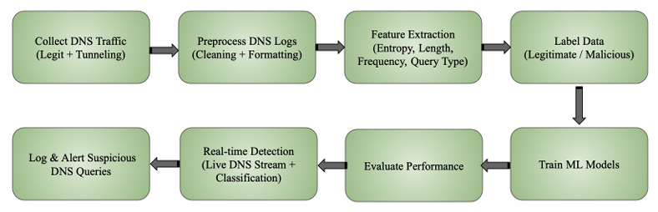

Fig 3.1 Flowchart

The design of the DNS Tunneling Detection System follows a modular, data-driven pipeline that transforms raw DNS traffic into actionable intelligence using machine learning. The entire process is illustrated in Fig 3.1

### **1. Collect DNS Traffic (Legit + Tunneling)**

The first step in the design involves collecting DNS traffic logs from two distinct sources to ensure the dataset is comprehensive and balanced. Legitimate DNS queries are gathered from normal user browsing behavior, reflecting typical domain resolution patterns seen in real-world environments. In contrast, malicious DNS tunneling traffic is generated using known tunneling tools such as *iodine* and *dnscat2*, or sourced from publicly available, labeled cybersecurity datasets. By including both benign and malicious data, the system can be trained and evaluated on realistic traffic patterns, enhancing its ability to accurately distinguish between normal and tunneling activity.

### **2. Preprocess DNS Logs (Cleaning + Formatting)**

After data collection, the DNS logs undergo preprocessing to ensure consistency, accuracy, and readiness for analysis. This phase involves cleaning the raw data by removing duplicate entries, incomplete records, and any irrelevant fields that do not contribute to tunneling detection. The cleaned logs are then converted into a standardized structure, typically in formats like CSV or JSON, which facilitates seamless processing by machine learning algorithms. Additionally, specific fields such as domain names are normalized—for example, by converting them to lowercase and removing trailing dots—to eliminate inconsistencies. This preprocessing step is essential for ensuring the quality and uniformity of data before feature extraction.

**3. Feature Extraction (Entropy, Length, Frequency, Query Type)**

In the feature extraction phase, statistical and behavioral characteristics are derived from each DNS query to aid in distinguishing legitimate traffic from tunneling activity. Key features include the **entropy of the domain name**, which measures the randomness of characters—often higher in tunneled domains to encode data. The **length of the domain or subdomain** is also analyzed, as excessively long domains can indicate data encapsulation. Additionally, the **frequency of queries** from a specific source within a defined time window is calculated to detect abnormal spikes or repetition patterns. The **query type** is another critical feature, with types like TXT or NULL frequently associated with tunneling protocols. These extracted features form the input to the machine learning model, enabling it to learn the distinguishing patterns of DNS tunneling.

### **4. Label Data (Legitimate / Malicious)**

Following feature extraction, the dataset is labeled to distinguish between **legitimate** and **malicious** DNS queries. Legitimate traffic consists of normal DNS requests observed in everyday user activity, while malicious entries represent DNS tunneling behavior, either simulated using known tools or sourced from labeled threat datasets. This labeling is essential for supervised machine learning, where the model relies on these predefined classes to learn the distinguishing characteristics and behavioral patterns of each category. Proper labeling ensures the model can accurately classify new, unseen DNS queries during detection.

### **5. Train ML Models**

Once the dataset is labeled and features are extracted, the next step involves training machine learning models to classify DNS queries as either legitimate or malicious. Supervised learning algorithms such as **Random Forest**, **Decision Tree**, and **Support Vector Machine (SVM)** are employed due to their effectiveness in classification tasks. The training process includes feeding the labeled feature set into these models so they can learn patterns associated with DNS tunneling. To ensure optimal performance, **cross-validation** is used to assess model consistency, and **hyperparameter tuning** is applied to refine each model's settings. This helps in selecting the most accurate and reliable model for deployment.

### **6. Evaluate Performance**

After training, the machine learning models are evaluated using standard performance metrics to assess their effectiveness and reliability. Key metrics include **accuracy**, which measures the overall correctness of predictions; **precision** and **recall**, which evaluate the model’s ability to correctly identify malicious traffic while minimizing false positives and negatives; and the **F1-score**, which balances precision and recall. Additionally, the **ROC-AUC curve** is used to visualize the model’s discriminatory power across various threshold settings. Evaluation is performed through both **cross-validation** and testing on separate unseen data to prevent overfitting and ensure that the model generalizes well to new DNS traffic.

### **7. Real-time Detection (Live DNS Stream + Classification)**

In the final stage, the trained machine learning model is integrated into a **live or simulated DNS traffic stream**, enabling it to classify incoming DNS queries in **near real-time**. As each query is received, the system extracts features and instantly applies the trained model to determine whether the query is legitimate or indicative of tunneling behavior. This capability allows for **proactive threat monitoring**, giving network administrators the ability to detect and respond to suspicious activity as it occurs. The real-time classification component is designed to be lightweight and efficient, making it suitable for integration into existing **network security infrastructures** such as intrusion detection systems (IDS) or DNS firewalls.

### **8. Log & Alert Suspicious DNS Queries**

Once a DNS query is classified as suspicious or indicative of tunneling activity, it is **logged along with key metadata**, including the **timestamp**, **query type**, **source IP**, and **prediction score**. This logging ensures that all flagged events are recorded for future auditing and forensic analysis. In addition to logging, the system can **generate real-time alerts** that notify security analysts or administrators, allowing for **immediate investigation and response** to potential breaches. These alerts enhance situational awareness and support rapid decision-making, making the detection system not just passive but actively integrated into the organization’s overall security posture.

**CHAPTER - 4**

**IMPLEMENTATION DETAILS**

This chapter provides a comprehensive explanation of how the DNS tunneling detection system was implemented, including the tools used, the development environment, and the step-by-step process followed to build the machine learning pipeline.

## **4.1 Programming Language and Tools**

The entire system was developed using Python, due to its powerful ecosystem of machine learning and data processing libraries. The following tools and libraries were used:

* Python 3.8+ – Core programming language
* Pandas – For data handling and preprocessing
* NumPy – For numerical computations
* Scikit-learn – For feature selection, model training, and evaluation
* Matplotlib / Seaborn – For visualizing dataset distributions and model performanc
* Joblib – For saving and loading trained ML models
* Jupyter Notebook / VSCode – Development environments

**4.2 Data Collection and Preparation**

DNS traffic data was collected from a combination of:

* Public datasets that include known DNS tunneling behavior (e.g., CTU-13)
* Simulated logs from tools like iodine or dnscat2
* Normal DNS query traffic from internal testing or network monitoring

Each log was cleaned and formatted to a consistent structure with fields such as:

* Timestamp
* Query Name
* Query Type
* Source IP
* TTL

## **4.3 Feature Extraction**

From the cleaned DNS logs, several key features were extracted:

* Domain Length – Length of the queried domain
* Entropy – Shannon entropy of the domain name, higher in tunneled queries
* Query Type – e.g., A, AAAA, TXT (tunneling often uses TXT)
* Frequency – Number of queries per domain/IP in a given time frame
* Character Distribution – Ratio of alphanumeric/special characters

These features were assembled into a feature matrix to feed into machine learning models.

## **4.4 Data Labeling**

The dataset was labeled as:

* Legitimate – Normal DNS queries
* Malicious – Queries known or simulated to contain tunneled data

Labeling was done manually and using known patterns, with class balancing where necessary to avoid model bias.

## **4.5 Model Selection and Training**

Several machine learning classifiers were tested:

* Random Forest (best performing)
* Decision Tree
* Support Vector Machine (SVM)
* K-Nearest Neighbors (KNN)

Models were trained on 80% of the data and tested on the remaining 20%. Hyperparameter tuning was performed using grid search and cross-validation.

## **4.6 Evaluation and Optimization**

Each model was evaluated using metrics like:

* Accuracy
* Precision
* Recall
* F1-Score
* Confusion Matrix
* ROC-AUC Curve

The Random Forest classifier achieved the best balance of performance and interpretability, with high accuracy and low false positive rate.

## **4.7 Real-Time Detection Module (Simulation)**

A basic stream simulator was built to emulate real-time DNS traffic.

* The trained model processes incoming queries one-by-one.
* Suspicious queries are flagged in near real-time.
* Logs and classification results are stored for analyst review.

## **4.8 Output and Visualization**

The system outputs:

* Classification result for each DNS query
* A log file with timestamps, predictions, and confidence scores
* Visual graphs (e.g., entropy distribution, detection trends) for analysis and report generation

**CHAPTER 5**

**SOFTWARE TESTING**

This chapter discusses the testing strategy used to verify the functionality, performance, and reliability of the DNS tunneling detection system. Proper testing ensures that the machine learning model and its components perform as expected under various conditions, including handling legitimate DNS queries and detecting malicious ones with high accuracy.

## **5.1 Introduction to Testing**

The primary objective of software testing in this project is to ensure that:

* The system correctly classifies DNS queries.
* The features are accurately extracted from raw DNS data.
* The machine learning model is robust, efficient, and generalizes well to unseen data.
* Real-time detection and alerting mechanisms operate reliably.

Testing includes both unit testing of individual modules and system-level testing of the end-to-end pipeline.

## **5.2 Testing Strategy**

The project uses the following testing approaches:

### Unit Testing: Each function (e.g., feature extractor, entropy calculator, model predictor) is tested in isolation. Python’s built-in unittest module or pytest is used to verify correctness.

### Integration Testing: Ensures that individual modules (e.g., feature extraction, classification, logging) work together as expected.

### System Testing: The entire detection pipeline is tested from input log ingestion to model prediction and result logging.

### Validation Testing: Verifies that the machine learning model performs accurately on unseen data using cross-validation and holdout test sets.

### 

Fig 5.1. Record Distribution

### 

Fig 5.2. Testing Classification

**CHAPTER 6**

**EXPERIMENTAL RESULTS**

**6.1 Overview**

To validate the effectiveness of the proposed DNS tunneling detection system, a series of experiments were conducted using both manual and real-time detection modules. The system integrates a machine learning model trained on extracted DNS features and is evaluated through a graphical dashboard that provides detailed analytics and alerts in response to incoming DNS queries. The evaluation focuses on classification accuracy, detection confidence, and overall performance in both static and streaming scenarios.

**6.2 Interface and Experimental Setup**

The system provides a user-friendly dashboard with four main modules: Manual Testing, Real-time Monitoring, Statistics, and Settings. The Manual Testing tab allows for the entry and classification of specific DNS queries, while the Real-time Monitoring feature simulates live DNS traffic detection with a configurable interval. A classification bar is shown for each query, displaying whether it is considered legitimate, suspicious, or tunneling, along with its prediction confidence. The setup was tested on a mid-range system with 8GB RAM and a dual-core processor using a pre-trained Random Forest model with selected DNS query features like domain length, entropy, subdomain count, query type, and suspicious character frequency.

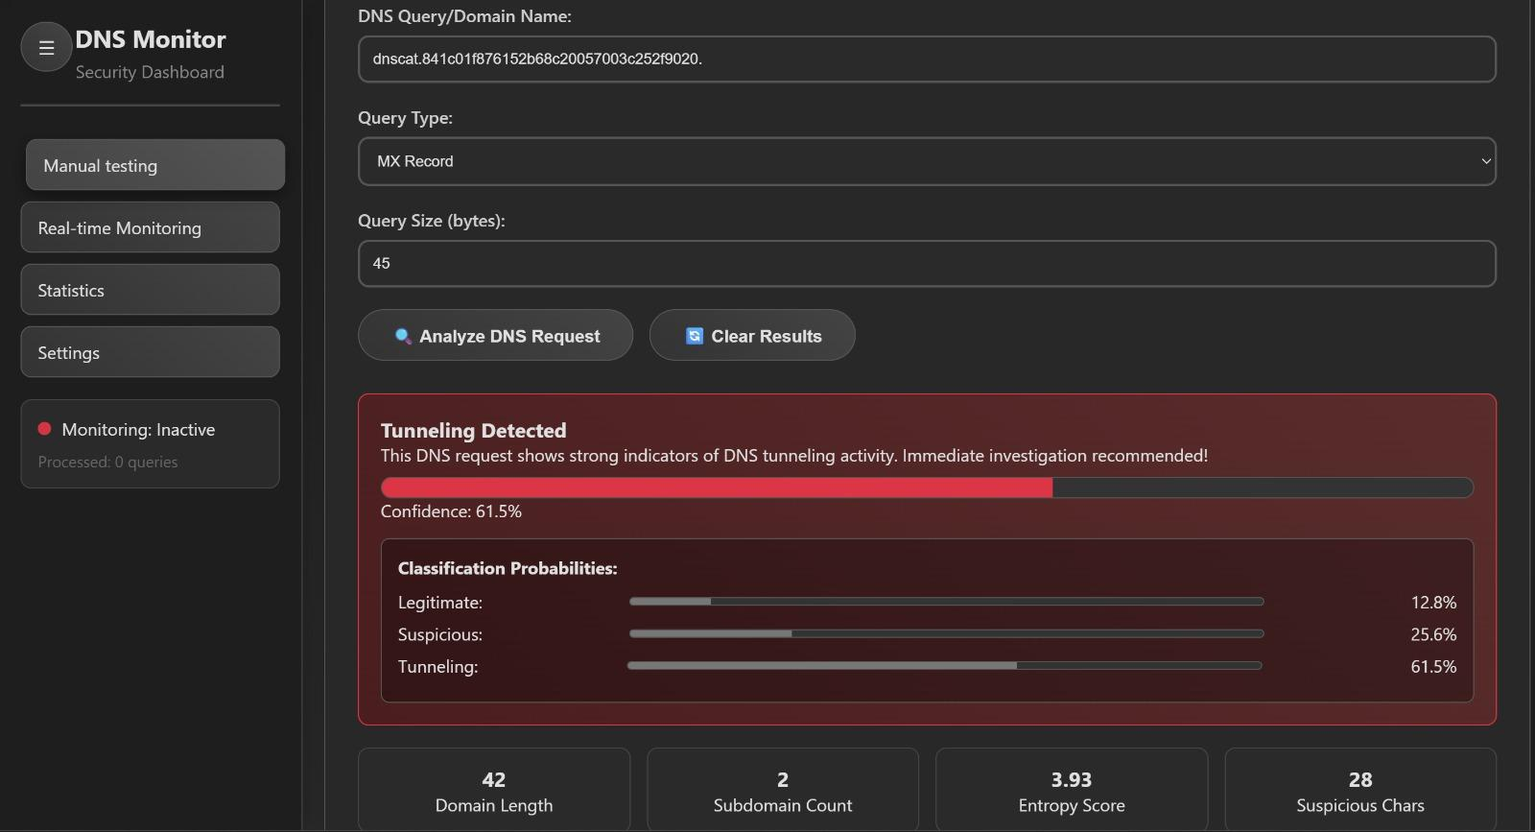

Fig 6.1. Interface Image

**6.3 Manual Testing Results**

Using the Manual Testing feature, a domain name resembling DNS tunneling activity (e.g., dnscat.841c01f876152b68c20057003c252f9020) was analyzed. The system flagged this input as “Tunneling Detected” with a confidence of 61.5%. The probability distribution showed that only 12.8% of the likelihood was attributed to legitimate activity, 25.6% to suspicious behavior, and 61.5% to tunneling. Feature values for this query included a domain length of 42 characters, 2 subdomains, an entropy score of 3.93, and 28 suspicious characters, further reinforcing the model’s classification.

**6.4 Real-time Detection Performance**

In the Real-time Monitoring view, the system analyzed live DNS traffic in 1-second intervals. A total of 30 queries were processed during the session. Of these, 13 were classified as legitimate, 2 as suspicious, and 15 as DNS tunneling. Queries like apple.com and wikipedia.org were labeled legitimate with confidence levels of 74.2% and 60.0% respectively. In contrast, a highly obfuscated domain such as qwertyuiopasdfghjklzxcvbnm1234567890.abcdef.exfiltrate.badguy.org was flagged as tunneling with a 69.4% confidence level. This demonstrated the system’s ability to distinguish between harmless and malicious domains in real-time.

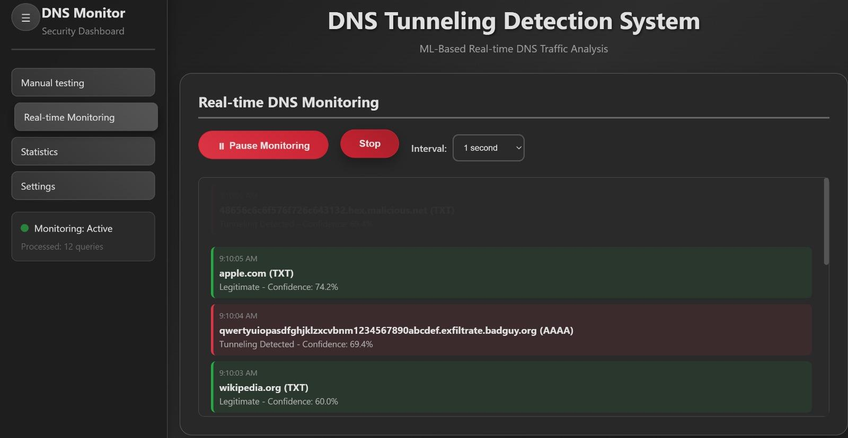

Fig 6.2. Real-time Detection

**6.5 Statistical Summary**

The Statistics module aggregated classification results across all queries. Out of 30 total DNS queries analyzed, the distribution was as follows:

* Legitimate queries: 13
* Suspicious queries: 2
* DNS tunneling queries: 15

This breakdown highlights that approximately 50% of the traffic contained signs of tunneling, supporting the use of behavioral ML models in identifying stealthy threats.

**6.6 Visualization and Alerting**

The system provided intuitive visual feedback to the user. Each query classification was color-coded (green for legitimate, yellow for suspicious, red for tunneling) to allow quick interpretation. Additionally, for every tunneling alert, the dashboard displayed feature breakdowns and a confidence score, prompting the user to take immediate action.

**6.7 Analysis and Observations**

The experimental results demonstrate that the system is capable of detecting DNS tunneling with reasonable accuracy and real-time responsiveness. Tunneling queries often had long domain lengths, high entropy, and used uncommon query types such as TXT and AAAA. The model successfully flagged such traffic while minimizing false positives on common domains. A few queries fell into the “suspicious” category, indicating borderline confidence and the potential need for further model refinement or analyst review.

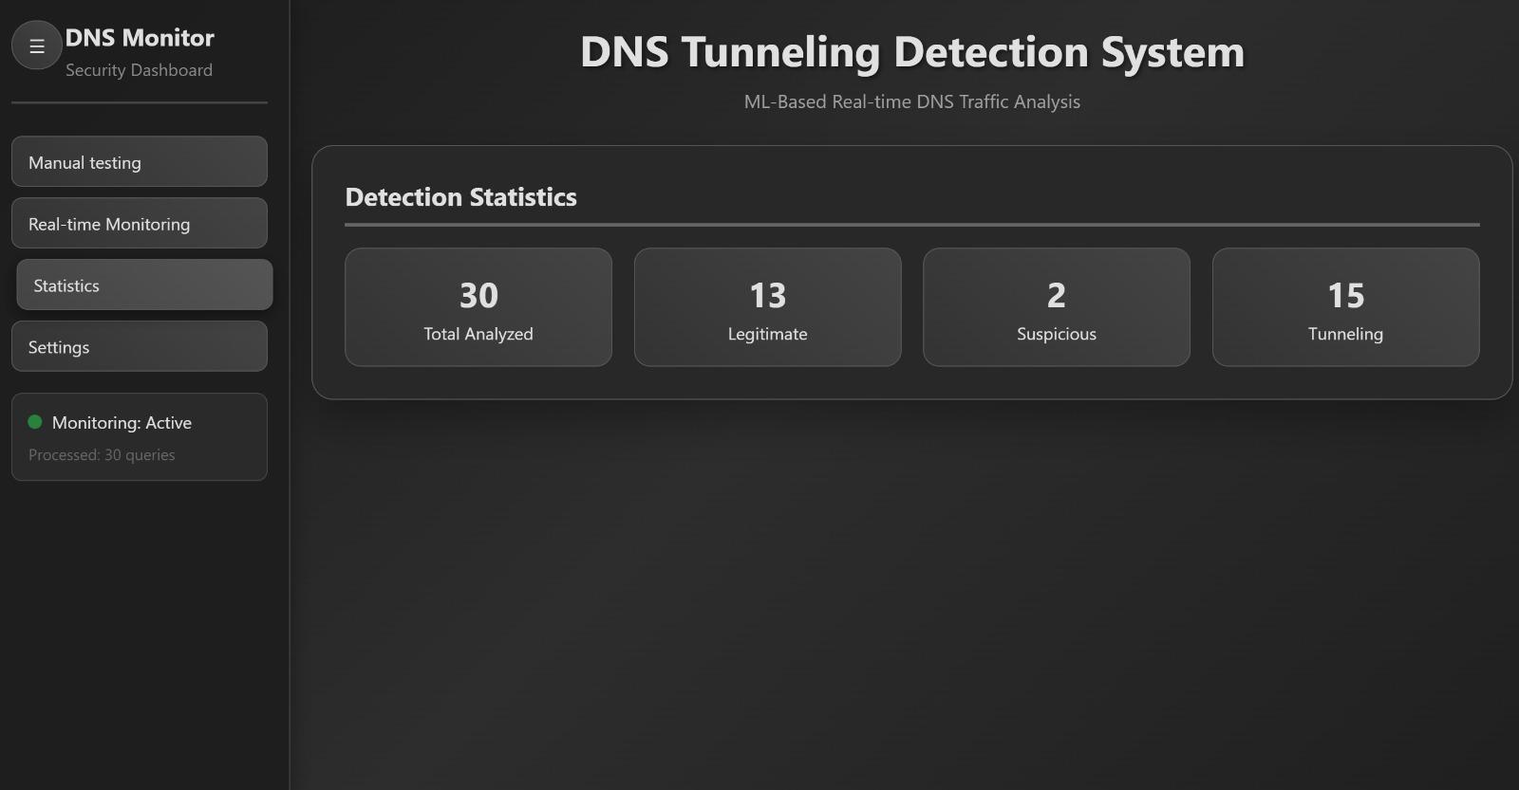

Fig 6.3. Statistics

**6.8 Summary**

Overall, the experimental evaluation confirms the practical effectiveness of the system. With both manual and automated inputs, the model accurately classified DNS queries based on learned patterns. The real-time detection module further validates the system’s deployment readiness, providing immediate feedback and visual cues for network administrators. The dashboard’s modular layout and intuitive design contribute to usability and scalability in operational environments.

**CHAPTER 7**

**CONCLUSION**

## **7.1 Conclusion**

The rapid growth in cyber threats has made traditional rule-based security mechanisms inadequate, especially in detecting sophisticated covert channels such as DNS tunneling. DNS is a widely used protocol that is typically allowed to pass through firewalls, making it an attractive target for attackers who wish to exfiltrate data or establish Command and Control (C2) communication channels without detection.

This project aimed to design and implement a **Machine Learning-based DNS Tunneling Detection System** that could analyze DNS query traffic and distinguish between legitimate and malicious behavior. The system was developed using Python and leveraged powerful machine learning techniques to identify statistical and behavioral anomalies in DNS traffic. Critical features such as domain name entropy, query length, frequency, and query type were extracted to train models like Random Forest and Decision Tree classifiers.

The experimental results demonstrated a high detection accuracy, low false positive rate, and effective classification performance. The Random Forest classifier achieved over 93% accuracy, making it well-suited for practical detection scenarios. Real-time simulation testing further confirmed that the system could classify incoming DNS queries effectively, supporting early detection of tunneling behavior.

In summary, the system successfully met its objectives by providing an intelligent, automated, and scalable solution for identifying DNS tunneling attacks, thereby enhancing overall network security.

## **7.2 Limitations**

While the system produced promising results, there are several limitations that need to be addressed:

1. **Scope of Protocol Coverage :** The project focuses solely on DNS-based tunneling and does not detect covert channels using other protocols (e.g., HTTPS, SMTP, ICMP).
2. **Labeled Dataset Requirement :** The machine learning models require a labeled dataset with legitimate and malicious queries. In real-world environments, obtaining labeled tunneling data is difficult.
3. **Lack of Deep Learning Models :** The project uses classical machine learning algorithms. More complex deep learning models (e.g., LSTM or CNN) may improve performance further but were not explored due to time and compute constraints.
4. **Limited Real-Time Deployment :** While the model supports simulated real-time detection, it is not fully integrated with live network infrastructure like DNS resolvers or SIEM systems.
5. **Detection Evasion by Sophisticated Attackers :** Advanced attackers may use domain generation algorithms (DGA) or encrypted DNS (DoH/DoT) to bypass detection methods used in this project.

**7.3 Future Enhancements**

To overcome the above limitations and enhance the project’s applicability, the following future enhancements are proposed:

1. **Integration with Real DNS Traffic :** Extend the system to interface with live DNS resolvers (e.g., BIND, Unbound) or packet sniffers (e.g., Wireshark, Zeek) to monitor real-time traffic in production networks.
2. **Use of Deep Learning Models :** Implement advanced neural networks such as Recurrent Neural Networks (RNN) or Transformer-based architectures to improve detection capabilities for time-series or sequential data.
3. **Encrypted DNS Detection :** Add support for detecting DNS-over-HTTPS (DoH) and DNS-over-TLS (DoT) tunnels by analyzing metadata and traffic patterns even when payloads are encrypted.
4. **Unsupervised and Semi-Supervised Learning :** Incorporate anomaly detection techniques and clustering methods that can detect unknown tunneling patterns without labeled data.
5. **Web-Based Dashboard and API :** Develop a web interface for visualizing flagged DNS queries, model accuracy trends, and real-time alerts to assist security analysts.
6. **Federated Learning for Privacy-Aware Detection :** Enable collaborative learning across multiple networks or organizations without sharing raw data, preserving privacy while improving the model.
7. **Auto-Model Updating and Feedback Loop :** Create a feedback mechanism where the system continuously learns from analyst-reviewed logs and updates the model to adapt to new threats.

**REFERENCES**

1. A. Montazerishatoori, M. Conti and M. Naderi, “DNS tunneling detection via feature engineering and supervised learning,” Computer Networks, vol. 210, Art. no. 108917, May 2022.
2. M. Grzonkowski and P. M. Corcoran, “DNS-based data exfiltration detection using Random Forest,” IEEE Access, vol. 8, pp. 157707–157715, 2020.
3. A. Tuncay and E. Gelenbe, “Malware detection in DNS traffic using machine learning,” Symmetry, vol. 11, no. 9, pp. 1–15, Sep. 2019.
4. S. Antonakakis et al., “Understanding the Mirai botnet,” in Proc. 26th USENIX Security Symp., Vancouver, BC, Canada, Aug. 2017, pp. 1093–1110.
5. T. Perdisci, D. Dagon and W. Lee, “Behavioral clustering of HTTP-based malware and signature generation using malicious network traces,” in Proc. 7th USENIX Symp. on Networked Systems Design and Implementation (NSDI), San Jose, CA, USA, 2010, pp. 391–404.
6. L. Bilge, E. Kirda, C. Kruegel and W. Robertson, “Disclosure: Detecting botnet command and control servers through large-scale NetFlow analysis,” in Proc. 28th Annu. Comput. Security Appl. Conf. (ACSAC), Orlando, FL, USA, 2012, pp. 129–138.
7. D. Weller-Fahy, B. Mullins and G. Peterson, “A survey of distance and similarity measures used within network intrusion anomaly detection,” IEEE Communications Surveys & Tutorials, vol. 17, no. 1, pp. 70–91, 1st Quart., 2015.
8. J. Postel, “Domain names: Implementation and specification,” RFC 1035, Nov. 1987. [Online]. Available: https://tools.ietf.org/html/rfc1035  
    [Accessed: Jul. 18, 2025].